**18.1.1**

One, and two, and three, and four. Are you OK?

Me? I'm fine

No. you're not. What’s wrong?

I have my first acting class tonight

You do. It's a big night

**I'm scared of acting class**

**Were you** **scared of class in** **medical school?** No, so don’t be scaredthe acting class /ˈmedɪkl/

**I was scared of class in medical school**

OK, never mine

What can I do want not scared?

I have got a nice idea. **Is Dan Blaze scared when he acts?** /ækt/

**No, Dan Blaze is never scared**

You're right! **Why is he never scared?**

**He never scared because he's a famous actor**

Yes, **how can we make you a famous actor?**

**I don't know.**

We make you look like the famous actor. I have a few things in my clothes, you can wear while in acting class. People say: Clothes make the man

Why is this a big night for Shen?

--> He has his first acting class

Benny wants to help Shen with his problem

How can Benny help Shen?

--> he can help Shen look famous

How can Shen look like an actor?

--> He can wear Benny's clothes

Is he sacred of thumder and lightning?

* No, he’s never scared of anything

Why are your scared of acting class?

* I’m scared because I’m not a good actor

I’m scared of going to the doctor

* How can we make you not scared?

Were you scared of riding hores when I was little

* Really? Why were you scared?

What’s wrong?

* I’m scared, but I don’t know why

**Conversation**Hey. What’s wrong? Are you feeling ok?

Well, tonight I have my first cooking class.

Cooking class. Is that why you feel bad?

Yes. I’m scared of cooking class.

**But you was scared of your acting class. Was you?(not sure)**

Yes, I was very scared my acting class last year.

Well. Never mind. That was last year. What can we do to help you now?

I don’t know.

I have a idea . I can come with you.

Why do you want to come with me?

So, you don't feel scared. And so I can learn something about cooking

You’re really good friend. Thanks

**Exercise**

Are you a medical student?

--> No, I'm a doctor now

Why are you excited?

--> I start ,y new job tomorrow

When you were a child, were you excited on your first day of school?

-> No, I was never excited about school

What's wrong?

--> I have a lot of work and I'm tired

What time is the meeting?

--> Sorry, I don't know

I'm a bad cook. What can I do?

--> You can take cooking classes

What can I wear to the meeting tomorrow?

--> Your green sweater is nice

Why don't you take the bus?

--> Because my apartment is near the office

18.1.2

Come out!

No, I don’t want to

Shen, you look awesome. **I really like the jacket**

**I think it’s ugly**

OK, OK. Fine. Try these! **I think it’s great**!

I think it not great

Yes, **It’s very cool**

**No, it’s very weird**

I really like this one

**I don’t really like it**, this is small

**It’s my favourite**

**It’s not very nice**

It’s my favourite

**I think it’s borring**

**It’s not very exciting**

**I think it’s perfect**. Now I scared of your clothes and not the acting class

What are Shen and Benny talking about?

* Clothes

At first, shen doesn’t want to come out of the bedroom because he doen’t like Benny’s jacket

When Shen finds something he really likes, Benny doesn’t like it

At the end, Benny laughs because Shen says: he’s scared of Benny’s clothes

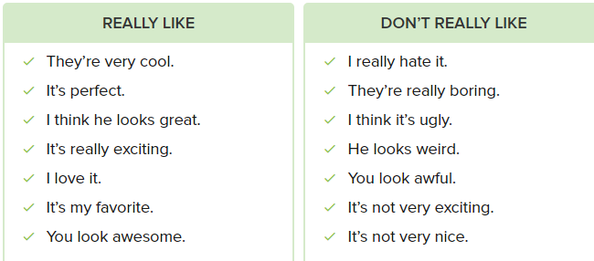

You look awesome in those shoes! I really like them

* Really? I think they’re ugly. I hate them!

Do you like pizza?

* Yes, it’s my favorite food

I don’t undertand this movie

* You’re right. It’s very weird

I really like my new sweater!

* Yes. I think it’s perfect with your new jeans! You look amazing!

I don’t like this dress. Do you?

* No, I think it’s ugly. Don’t buy it!

I have new job! I’m really excited!

* I can see that you look really happy!

How’s you English class?

* It’s great! I think our new teacher is very cool!

I think that actor is great. He’s my favorite!

* Really? I think he’s boring

**Conversition**

Here is a photo some of us in the first day class. We are reading a script. That’s Milon in the left. Cool huh?

Yes, I think is an awesome photo

And here is a photo’ my friend, Bill. Do you like it blue hair?

I think Bill looks awesome. But his hair? sorry, I think it really ugly!

And here is one of my favorite, It’s my friend Caro, Kazy Coro. What do you think?

I think it’s a really funny photo. His hair is weird, and his clothes are very crazy!

OK, here is a last one, but not for my acting class. It’s Smantha. She wearing my shirt. Smantha think the photo boring and not very nice. What do you think?

I think it a really nice photo, Smantha is awesome, and that big shirt is very funy

**Exsercise**

I don’t like this book. I think it’s boring.

I really love this sweater. It’s my favorite

I think I look terrible in these jeans.

* Then don’t buy them.

Is this actor your favorite?

* Yes. I think his films are really exciting.

What’s funny?

* This photo of you! You look weird in that big shirt.

I really think the pizza at that restaurant is terrible. I never order it.

Tanya really hates her boss.

* I know! She thinks he’s really mean to her.

Why are you wearing that old jacket?

* Because it’s perfect with my red shirt.

**18.1.3**

Hello sutdents! My name is Mary Hartman. And I am your acting teacher. To day is a first class, and...

Is it acting class?

It is, who are you?

My name is Shen

Ah yes Shen, coming, shit down, we are studying. Acting is a hard job, but with my hope, you can all be good actors. Watch me! Listen to my introduction, and you can be the next Dan Blaze

I can be the next Dan Blaze?

Sure. I want ask you a question. What do you love doing?

I love going museums

OK. What do you love doing?

I love dancing

What do you love doing?

I love watching TV. No, I love eating. I love eating and watching TV

What do you love doing?

I love singing

What do you love doing?

I love playing golf

What do you love doing?

I love acting

Yes...Shen, that's right, You are wrong. Shen is right. You don't love singing, you don't love dancing, you don't love reading and watching TV

We don't?

No, you love acting. Say it, say: I LOVE ACTING

I love acting....

Actually, only love acting. Now tell me, what do you hate doing? You first

I hate reading

Wrong!

I hate working

Wrong!

I hate eating pizza

Wrong!

I hate drinking coffee

Wrong! Who hate drinking coffee?

What do you hate?

I hate doing math

Wrong!

I hate not acting

Buzz, that's right, Shen, you are right. Listen to Shen, he is only real actor here. From now one, you hate not acting, you love acting. Who want to do some acting exercises?

**Practice**

Sarah , what do you love doing?

I love going shopping with my friends.

Lily, do you love going to acting school?

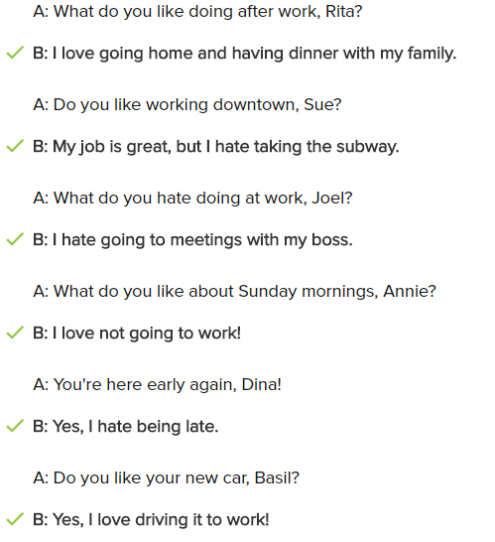

**Conversation**

Good job today Shen, Can I ask you some questions?

Sure! I love answering questions

I know you’re from China, do you like living in New York city?

Yes, I love living in New York city. It is exciting city

I know you love acting, but what do you love doing when you not acting?

Good question! I love going to museums, and I love watching TV with my roommate Benny

And why are you taking acting classes?

You know the answer to that! Becasue I love acting!

Is there anything you hate doing? and please don't tell me you hate you not acting, I know that

OK...I'm thinking...Yes, I hate doing Benny's laundry!

**Excercise**

Turn on the TV! The big tennis match is starting!

--> Good! I love watching tennis on TV

I really like the pizza Gino's. Can we order one for delivery?

--> Goof idea! It's my favorite

Why do you like Sunday so much?

--> Becasue it's my day off, and I love staying in bed until 10 o'clock

I hate taking the bus to work

--> I know. It's expensive and very slow!

How's your new apartment?

--> Great! It's very near my office,a nd I love walking to work

Maya: Why don’t you like your new job?

--> Because I hate working on weekends

I love shopping at the new clothing store!

-->Hanna: I know, but it’s very expensive.

Ali: You have a terrible boss. Why do you stay at that company?

🡪I love having money

**Leason Exercises**

I’m scared of acting class. I think I have an idea

I think its ugly

I love watching TV

You don’t look good. **What’s wrong?**

* I have a headache and my back hurts

I never have any time to ride my bike. What can I do?

* I think **I have an idea**. Don’t take the train and ride your bike to work

Is Dan Blaze a good actor?

* **Sorry, I don’t know**. Who is Dan Blaze?

**Are you excited** to fly to Mexico?

* No, I’m scared of flying in airplanes

**Why are you nervous about** cooking dinner?

* Because I don’t know what food my new friends like

Let’s go to the American Pie diner for lunch

* Good idea! I think the food there is **delicous**

Why are you looking for a new job?

* My job is **boring**! I need to do something interesting

You always watch a lot of basketball on TV

* That’s because it’s **my favorite sport**

Oh, this table is perfect for our living room!

* I think it’s ugly. It’s a really weird color. Let’s look for a nice one

Do you like doing excercies for you back?

* No, I don’t really like doing them. They hurt sometimes

I really like visiting art museums on the weekends

* Not me! I hate going to them. They’re boring

What do you like doing when you are not working?

* I love drawing pictures of people

I don’t like washing and drying my clothes

* No one like doing laundry. It’s a lot of work!

What do you love about your job?

* I love talking on the phone to customers

What’s wrong with your office at the new job?

* I really hate not being near a window

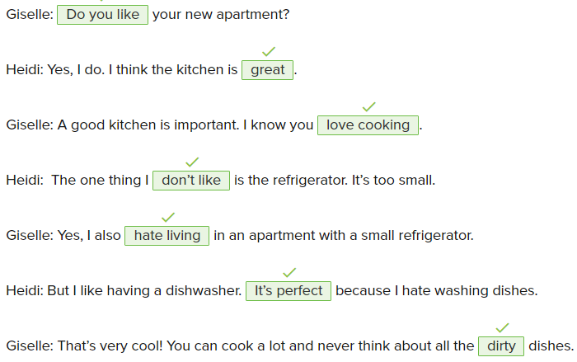

Workbook

1/8

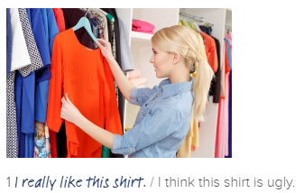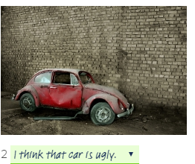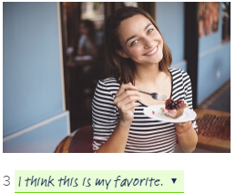

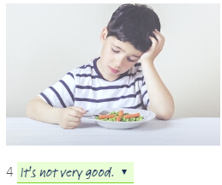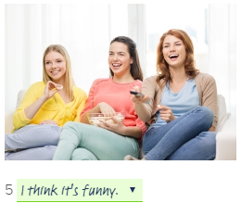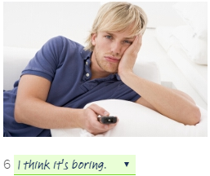

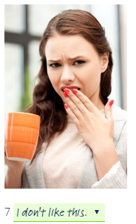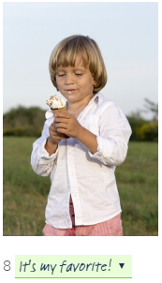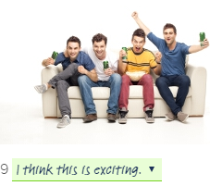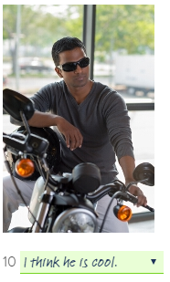

2/8

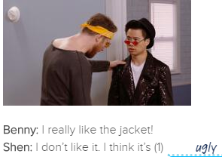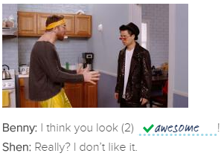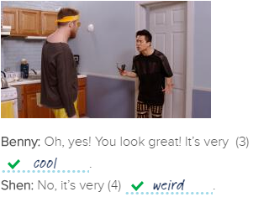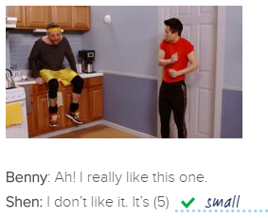

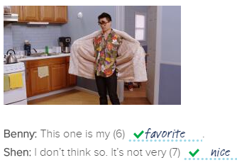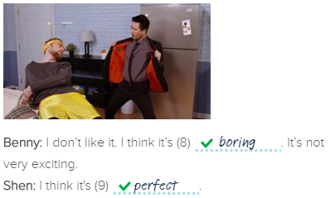

3/8

1 golf? / do / playing / you / like

Marco: Aanya, do you like playing golf?

2 on / the phone. / I / talking / like / don't

Sofi: I don't like talking on the phone.

3 Marco / people. / new / meeting / loves

Marco loves meeting new people.

4 Playing / games. / love / Shen and Benny

Shen and Benny love playing games.

5 Shen / sleeping / late. / hates

Shen hates sleeping late.

6 old clothes. / wearing / Aanya / hates

Aanya hates wearing old clothes.

7 eating / like / good / food. / I

I like eating good food.

8 his apartment. / doesn’t / Diego / cleaning / like

Diego doesn't like cleaning his apartment.

4/8

1 he / like / run

He likes running.

2 she / love / read

She loves reading.

3 they / not / like / cook

They don't like cooking.

4 he / hate / clean / his apartment

He hates cleaning his apartment.

5 we / like / go / to the movies

We like going to the movies.

6 he / not love / meet / new people.

He doesn't love meeting new people.

7 they / like / help / people

They like helping people.

8 she / not like / buy / food

She doesn't like buying food.

9 we / hate / work

We hate working.

5/8

Mary: Are you OK, Shen?

Shen: No, I'm not. I'm scared.

Mary: Why are you scared?

Shen: I'm scared because I'm not a good actor.

Mary: You can be a good actor, Shen.

Shen: Really?

Mary: Yes, you can. Do you like acting?

Shen: Yes, I love acting.

Mary: Do you hate not acting?

Shen: Of course!

Mary: Come to my class. I can make you a good actor.

Shen: I can be the next Dan Blaze!

Mary: Yes, Shen. You really can.

6/8

1 She **doesn't like playing** any sports. (not / like / play)

2 I **like going** out with friends. (like / go)

3 He **hates cooking**. (hate / cook)

4 Shen **loves acting**. (love / act)

5 I don't **like dancing**. (not / like / dance)

6 He **likes going** to museums. (like / go)

7 Natasha **hates riding** in cars. (hate / ride)

8 The children **love eating** pizza. (love / eat)

9 They **love drinking** coffee. (love / drink)

10 Sofi **likes working** in a restaurant. (like / work)

7/8

Are you okay?

-> Yes, I'm fine.

Are you in acting school now?

-> No. I'm an actor now.

I was scared of the dark when I was a child.

-> Really? Why were you scared?

Do you like this dress?

-> Yes, I do. I think it looks great on you.

Are you excited about acting class?

-> No. I'm scared!

I think this sweater is nice.

-> Really? I think it's ugly.

Do you like waking up early?

-> No, I hate it!

I'm hungry. Can we order food from Maddie's?

-> Great idea. It's my favorite.

I like watching Dan Blaze movies.

-> Really? I think they are boring.

8/8

My name is Brian. I want to tell you about what I like and dislike. I like a lot of things, but I also dislike a lot of things. My favorite food is pizza and chicken. I also love eggs. My favorite drink is coffee. I also like water. I hate beef. I also think that beans taste weird. I don’t like them. I hate cola. I don’t drink it.

My favorite sport is football. I love watching it on TV. I watch it every weekend. I also love playing football. I play with my friends in the park. I hate golf. I think golf is boring. I have a lot of hobbies. I love reading, running, and cooking. I dislike computer games. I don’t play them.

I like going to school and learning, but I hate tests. I’m always nervous when I take tests.

I’m thirsty – Would you like something to drink?

What’s your twin sister like? – She is sweet and she looks like me

You are not like me because you hate me

Do you like chips? – No, I don’t

Does she like football? – No, she doesn’t

What’s your apartment like? – It’s big and nice

Would you like to dance? – No, thanks, I don’t know how to dance

Don’t you like strawberries? – No, I don’t